The title of the thesis should be set in Arial font, 14 pounds, bold and centered. The paragraph set should be 3 pounds between the following paragraph and 6 pounds between the ahead paragraph, no line breaks when a line can not hold all content.
Jack¹, Tom^{2*}, Jean³
1 Department of Electronic Engineering, The Chinese University of Hong Kong, Sha Tin, New Territories, Hong Kong, China
2 Department of Automation and Mechanical Engineering, The Chinese University of Hong Kong, Sha Tin, New Territories, Hong Kong, China
3 School of Control Science and Engineering, Shandong University, Jinan, Shandong, China
*Corresponding Author
Keywords: format requirements; papers; conference
Abstract. The publication requirements for the official papers of this conference are given. Please carefully edit and type your papers in strict accordance with the requirements. Contents above the Keywords are Aria fonts, centered typesetting, and keywords must present in all the articles. Keywords should show before the introduction and the Abstract. The Abstract should be set 18 pounds between the ahead paragraph. The Abstract begins with the New Roman font, 12th font, and the justification.
1.Introduction
First of all, congratulations on your paper being accepted by this conference. In order to successfully and with high-quality do the publication of the collected papers of this conference, this paper gives the format requirements of the final version of the papers. Please be sure to edit and type your paper according to the paper format given in this paper, so that the papers submitted can be successfully selected for the conference papers. The organizing committee of this conference is very grateful for your cooperation and support.
2. Paper format
This paper gives a description of the format of the paper by taking the MS Word 2003 version platform as an example.
2.1 page setup
Paper mould: A4 (21 cm wide, 29.7 cm high).
Margins: 2.5 cm above, 1.5 cm lower, 2 cm left, 2 cm right.
2.2 Line spacing setting
The line spacing of the full text is set to single line spacing, and the first line of the paragraph is indented by 0.5 cm.
2.3 Font Settings
2.3.1 The font is defined as follows:
The title of the thesis should be set in Arial font, 14 pounds, bold and centered. The paragraph set should be 3 pounds between the following paragraph and 6 pounds between the ahead paragraph, no line breaks when a line cannot hold all content.
The author's name ⎯ 14 pounds Arial centered. The paragraph set should be 6 pounds between the ahead paragraph; the work unit ⎯ 11 pounds Arial centered, The paragraph set should be 6 pounds between the ahead paragraph (the order should be work unit, city, zip code, country; “keywords” ⎯ 11 pounds Arial bold, keyword content 11 pounds Arial, The paragraph set should be 18 pounds between the ahead paragraph; “Abstract” ⎯ 12 pounds Times New Roman Bold, summary content 12 pounds Times New Roman, The paragraph set should be 18 pounds between the ahead paragraph. The summary is followed by introduction, which is a must.
2.3.2 The specific requirements of the titles in first, second and third levels are as follows:
Level 1 title ⎯ 12 pounds Times New Roman bold at the top line, The paragraph set should be 18 pounds between the ahead paragraph, and 6 pounds between the following paragraph; Title below the second, third and third levels and text ⎯ 12 pounds Times New Roman font (cannot be bold); Table title ( The note is a must, starting with word “Table”), the title of the figure (the figure must have a legend, and the legend begins with Fig or begins with Figure) ⎯ 12 pounds Times New Roman font, centered. The content in the Tables and the figures ⎯ 12 pounds Times New Roman Fonts, Tables and figures are numbered starting from number 1; the text paragraph is indented by 0.5 cm.
The font of the reference in English should be 12 pounds of Times New Roman, and the references are labeled [1], [2] in the text.
2.4 Figures and Tables
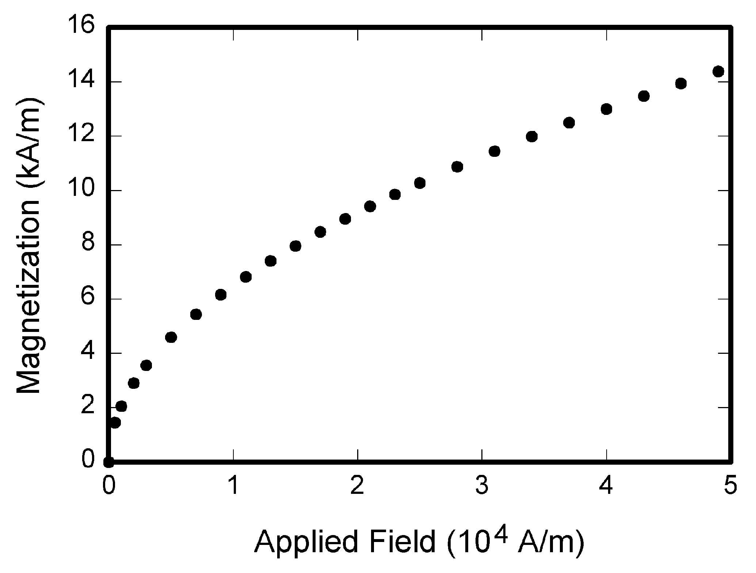
Fig1 figure title should be the corresponding descriptive text of the figure
Table1 Table title should be the corresponding descriptive text of the Table
Table title | Column Table title
 | sub-title | sub-title | sub-title
1
2
3
4
5
The width of the figure and Table should not exceed the width of the column. The title of the figure should be centered below the figure, and the Table title should be centered on top of the Table. Avoid placing a figure or Table before the mentioned paragraph.
The accuracy of the figure and the Table should not be lower than 300dpi, and the clarity of the picture must be guaranteed.
2.5 Mathematical formulas and symbols
Formulas must be edited with the formula editor and with a center layout, and you shall not use screenshots. When the formula editor is used:
Functions and variables are in italics, and matrix vectors are in bold italics.
The size is 10 pounds, the superscript and subscript is 6 pounds, the superscript and subscript in sub-level is 5 pounds, the symbol is 14 pounds, and the sub symbol is 9 pounds.
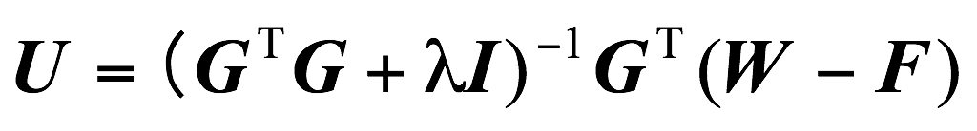 (1)
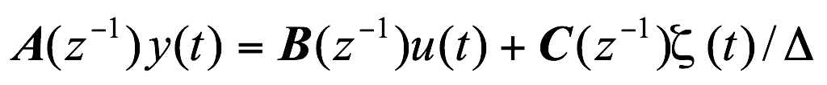 (2)
Each formula should be given an appropriate number and the formula number should be right aligned. The paragraph set of the formula before and after the following paragraph should be 6 pounds.
2.6 Head area
The upper part of the first page of each paper sample is the head area. In the head area, please type the English title, author, unit, keyword, and Abstract.
3. Notes
Do not add page numbers to the whole paper.
The page must be set up strictly in accordance with the requirements of this article. It is strictly forbidden to appear any part of the text, symbol or chart in the blank area of the margin.
If you encounter a problem with the format of the paper not covered in this article, the author can first refer to the “English paper format” requirements provided on the conference website. If the “English paper format” does not address the issue, the author can adopt the conventions of other academic papers or consult the conference secretariat.
A simple and easy way to typeset is: first, paste the content of the paper into the template; second, the content is pasted by the format brush; finally, delete the original content of the template. In this way, the format of the paper type, page setting, font, line spacing, etc. can be kept unchanged
4. Conclusion
In conclusion, any paper must have a conclusion, which is the result of a paper argument.
If the reference is in Chinese, please be sure to translate it into English. It is recommended to use the Chinese and English information provided in the reference itself (most of the documents can be found in the corresponding English in the CNKI). References should be titled as references instead of perface. Each article must have references. As to the reference format, it is recommended to search directly in Baidu academic search the topic, then the article reference. The GB format can be copied, the line spacing selection is the minimum-14.4 pounds; 6 pounds between the following paragraph.
Please be sure to edit and type your paper in accordance with the paper format given in this article.
Acknowledgement
This article is one of the phased results of the General Project “XXXX Research” (xxxxxxx) of the National Social Science Fund.
References
[1] Zhang K R , Mou J X . The Design of Digital Servo-Position Control System Based on LM629[J]. Journal of Measurement Science & Instrumentation, 2010(S1):72-74.
[2] HIROKIK, MINORUA, YASUOK, ET al.RoboCup: a challenge problem for AI and robotics. HirokiK. RoboCup-97: Robot Soccer World Cup [C]. Berlin: Springer, 1998.38-43.
[3] Zhizhong Yin. Application of FPGA control DC motor servo system [J]. Inner Mongolia Science and Technology and Economy, 2008 177 (23) 101-103.
[4] Joerg Christian Wolf, Phil Hall, Paul Robinson, Phil Culverhouse. Bioloid based Humanoid Soccer Robot Design, 2007.
[5]Wu Chuan-yu, He Lei-ying, Design and Realization of Instructional RPPR-Robot, Research and Exploration in Laboratory.2007, 26(10)
[6] Nishiwaki K,Kagami S. High Frequency Walking Pattern Generation based on Preview Control of ZMP, IEEE International Conference on Robotics and Automation. 2006.
[7] Chen Nan and so on. For the field of industrial and highly interconnected, TI launched a new Sitara ARM9 microprocessor. [J]. Global Electronics, 2010 (5) 86-87.
[8] Vision Heading Navigation Based on Navigation Curve [A]. Proceedings 2010 International Conference on Intelligent Computing and Integrated Systems[C]. 2010.
[9] Chen Nan and so on. For the field of industrial and highly interconnected, TI launched a new Sitara ARM9 microprocessor. [J]. Global Electronics, 2010 (5) 86-87.
[10] Jonghoon ZMP Park,Youngil Youm.General ZMP Control for Bipedal Walking. IEEE International Conference on Robotics and Automation. 2007.
[11] Chunmei Xu. Mechanical servo system based on fuzzy neural network for complex control [J]. Control Engineering .2010:17 (2):146-148.
[12] Zhijun He. LM629-based motor servo control system design [J]. Mechanical design and manufacture .2009 (2) 40-42.

